Karolina Konopka, Ahalya Pitchaikannu , Priyadharshini Pichai
4-25-2022

Wayne State University
STOCK PREDICTION APPLICATION
DSE 6300- DATA SCIENCE APPLICATIONS DEVELOPMENT -PROJECT REPORT

Contents

Abstract: 2
Introduction: 2
Long Short Term Memory Network 2
Docker Flask Application 3
Apache Kafka 3
Methodology: 4
Import Libraries: 4
Define constants 5
Pull Data from Yahoo Finance: 5
Creating Dataframe: 5
Normalizing the dataset: 6
Training the model: 6
Model Fitting: 6
Prediction results: 8
Flask Application Docker: 9
KafkaTopic 11
Conclusion and Summary: 13
Appendix: 14
Reference: 14

Abstract:
The aim of the project is to create an application to predict the values for user selected stock. Stock market forecasting is a popular and important study in financial and academic fields. Many methods like technical analysis, fundamental analysis, time series analysis and statistical analysis are used to predict the price in stock markets. The aim of the project is the predict the value of the financial stocks using Yahoo Finance Data (Webscraped), although stock market can never be predicted with hundred per-cent accuracy due to its vague domain, this paper aims at proving the efficiency of prediction models (LSTM- Long Short Term Model) for forecasting the stock market price. Python API and Docker will implement to create the application for stock market prediction. This application allows user to choose stock and its predicted values.
Key words: Prediction, LSTM, API.
Introduction:
A stock market is a public market where you can buy and sell shares for publicly listed companies. Stock market prediction and analysis are some of the most difficult jobs to complete. There are numerous causes for this, including market volatility and a variety of other dependent and independent variables that influence the value of a certain stock in the market. These variables make it extremely difficult for any stock market expert to anticipate the rise and fall of the market with great precision.
However, with the introduction of Machine Learning and its strong algorithms, the most recent market research and Stock Market Prediction advancements have begun to include such approaches in analyzing stock market data.
Long Short Term Memory Network:
Here, we are using a Long Short Term Memory Network (LSTM) for building our model to predict the stock prices of the Russell 1000 index pulled from Wikipedia.
LSTMs are a type of Recurrent Neural Network for learning long-term dependencies. It is commonly used for processing and predicting time-series data.
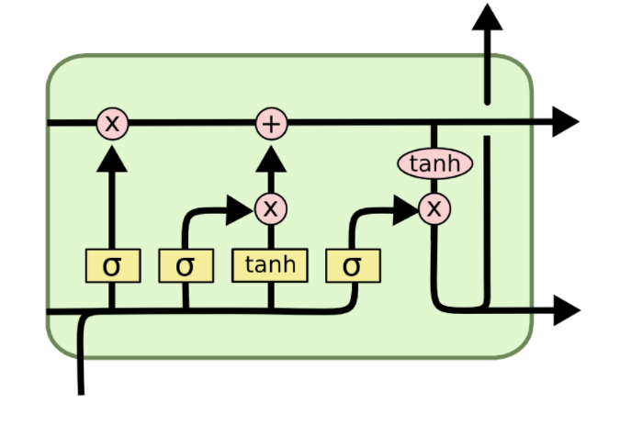
From the image on the top, you can see LSTMs have a chain-like structure. General RNNs have a single neural network layer. LSTMs, on the other hand, have four interacting layers communicating extraordinarily.
LSTMs work in a three-step process.
The first step in LSTM is to decide which information to be omitted from the cell in that particular time step. It is decided with the help of a sigmoid function. It looks at the previous state and the current input and computes the function.
There are two functions in the second layer. The first is the sigmoid function, and the second is the tanh function. The sigmoid function decides which values to let through (0 or 1). The tanh function gives the weightage to the values passed, deciding their level of importance from -1 to 1.
The third step is to decide what will be the final output. First, we need to run a sigmoid layer which determines what parts of the cell state make it to the output. Then, we must put the cell state through the tanh function to push the values between -1 and 1 and multiply it by the output of the sigmoid gate.
Docker Flask Application:
Docker is an open-source application that allows administrators to create, manage, deploy, and replicate applications using containers.
Flask is a web micro-framework that is built on Python.
The app directory will contain all files related to the Flask application such as its views and blueprints
Apache Kafka:
It is one of the events streaming application and it combines three key capabilities, so that we can implement for event streaming end to end with a single tested solution:
- To publish (write) and subscribe to (read) streams of events, including continuous import/export of our data from other systems.
- To store streams of events durably and reliably for as long as we want.
- To process streams of events as they occur or retrospectively.
Kafka is a distributed system consisting of servers and clients that communicate via a high-performance TCP network protocol. It can be deployed on bare-metal hardware, virtual machines, and containers in on premise as well as cloud environments.

Methodology:
The most crucial steps for creating the stock prediction application are as follows:
Import Libraries:
All the required libraries are imported to create the stock market application in python
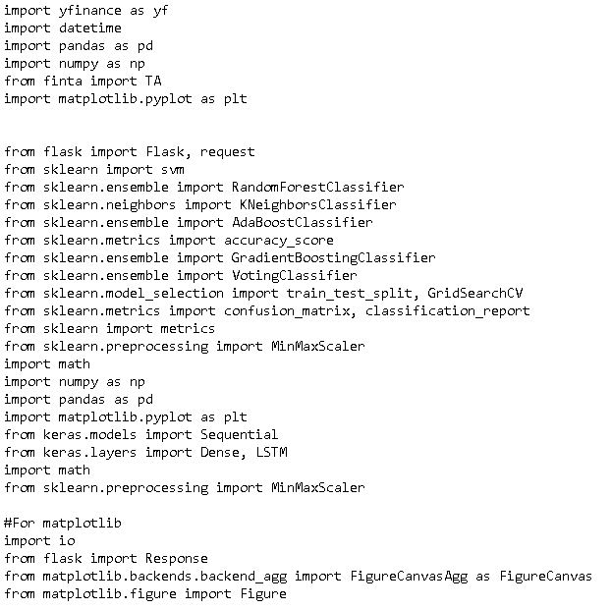

Defining the constants:
The constants are defined to retrieve the historical data from the Russell 1000 index and the sample rate of the historical data.
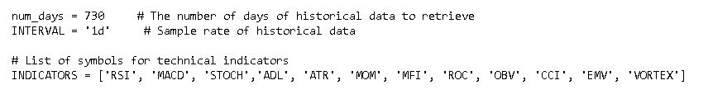

Pull data from Yahoo Finance:
Live streaming data is pulled from yahoo finance using user selected stock with the following code

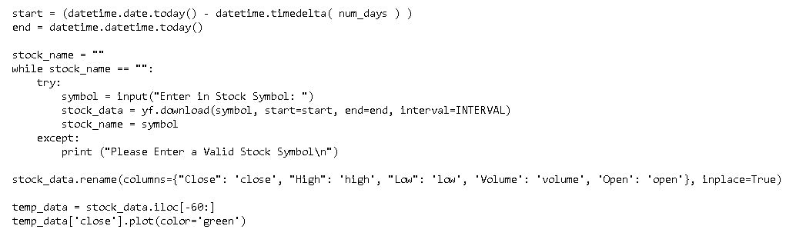

Creating Data frame:
The prediction model is trained by initially creating the data into array followed by normalization

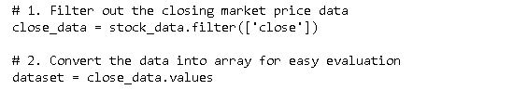

Normalizing the Dataset:
Dataset is normalized to remove the redundancy in the data to get accurate results.

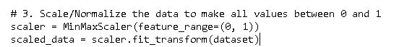

Training the model by creating x and y train data:
Training data is trained using the model LSTM and Adam Optimizer with 10 epoch to get minimum loss and maximum accuracy
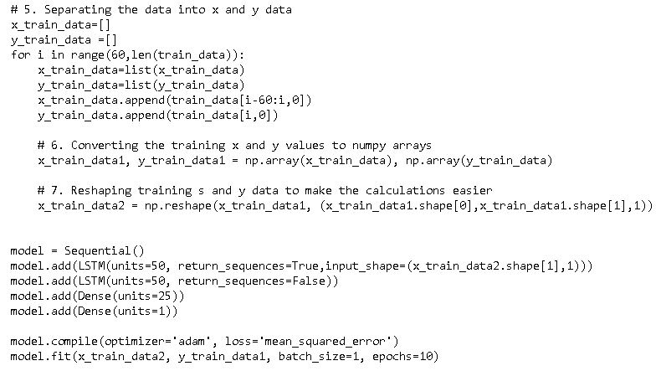

Model fitting:
The trained LSTM model is tested in the test data set using the following code and gets an accuracy of about 90% - 99%

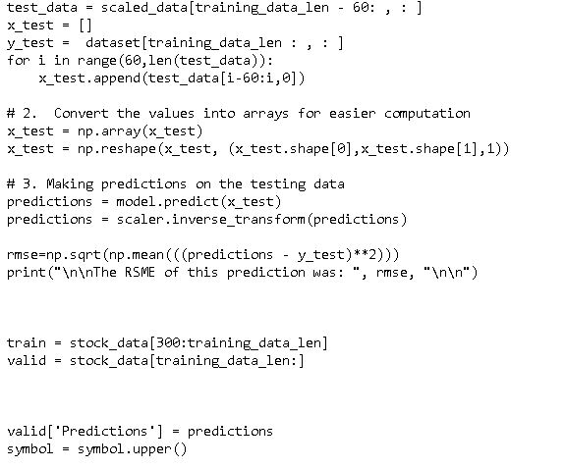
Below is the screenshots of the python code ran on the terminal, after it ran successfully it will ask for the stock symbol

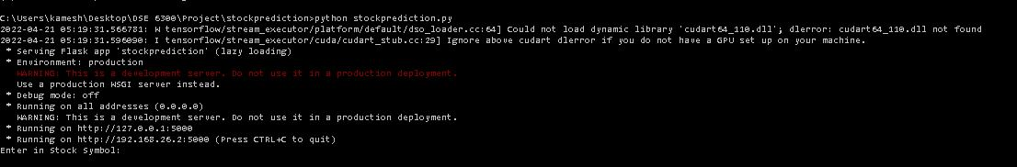

After entering stock symbol, it will run to 10 epochs and will provide the root square mean error (RSME). For instance, we got the RSME 5.234 for apple stock.

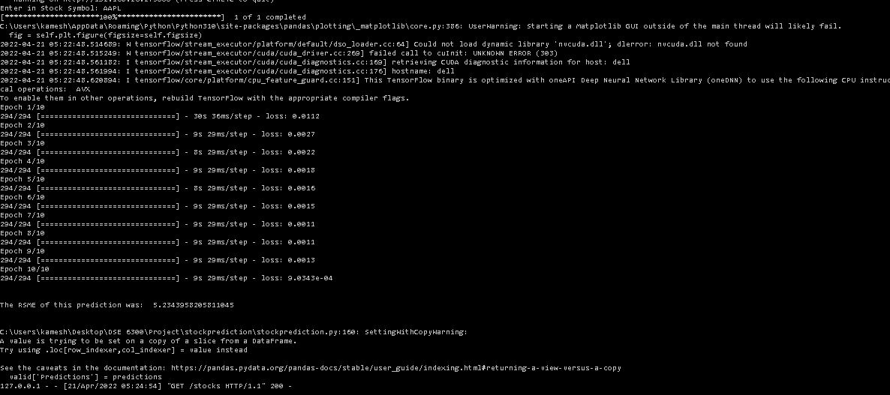

After all the epochs and the RSME are shown, now the predicted results will be appeared in the local host. Screenshot for Apple stock (AAPL) is attached below.

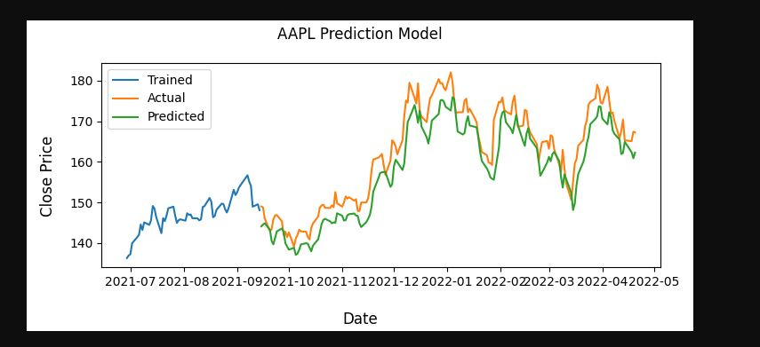

As we can see above, the model can predict the trend of the actual stock prices very closely. The accuracy of the model can be enhanced by training with more data and increasing the LSTM layers.

Flask application using Docker:
Flask application created using Docker and the steps are as follow:
Docker images are built with the command docker build –t with the image name as showed below in the screenshot
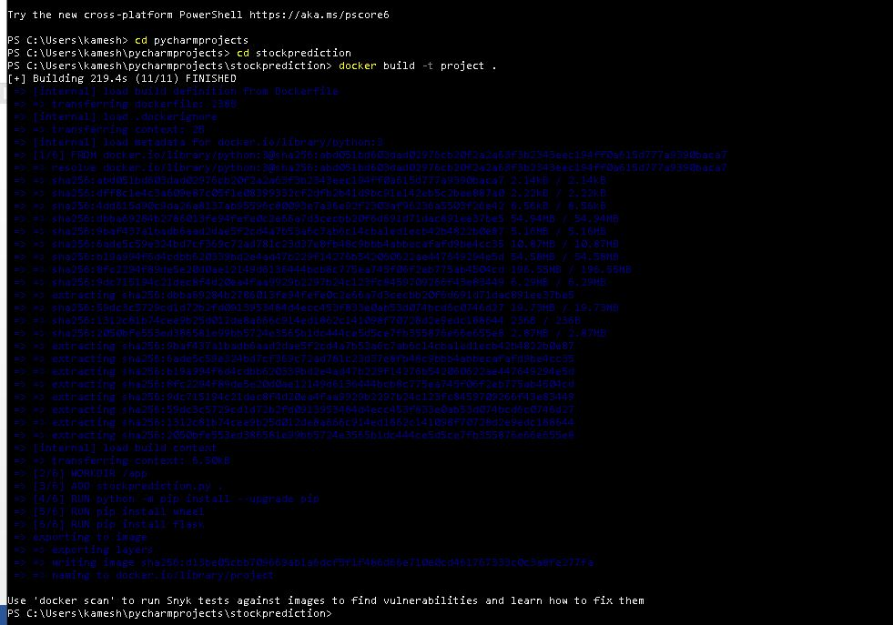

The build docker image was checked with docker images command; it will show all the docker images built so far on the machine. Screenshot attached below

The created image ran on the docker using docker run –d –p with the port number 5000:5000

The successfully running docker checked in the docker application as follow:

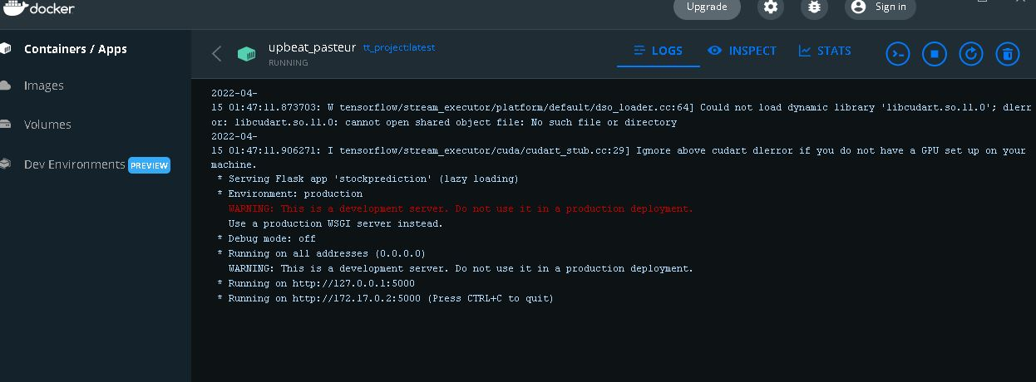

Apache Kafka:

Initial step is to run the docker-compose up command in the windows power shell , Example screenshot is attached below

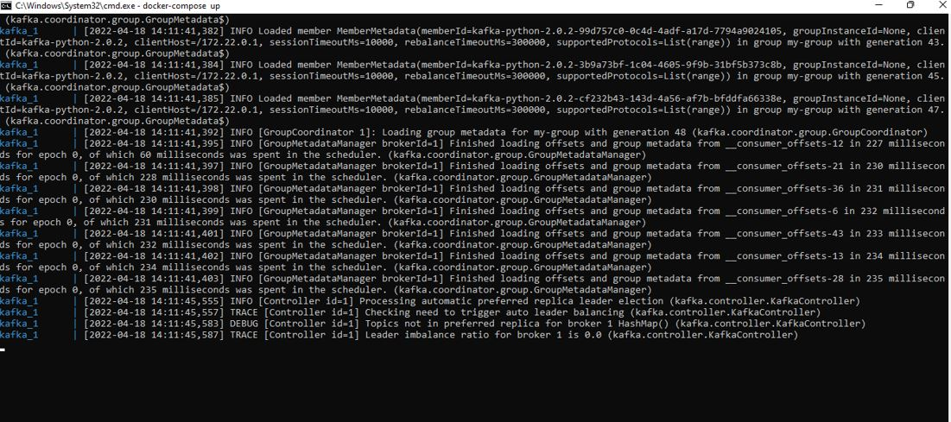

Once the docker compose is up and running, the kafka producer is called from one terminal , after the producer ran successfully the docker consumer is called from another terminal. Finally, the producer will ask the consumer for the stock symbol to predict the results in Kafka topic. Attached is example screen shot of the model running in kafka

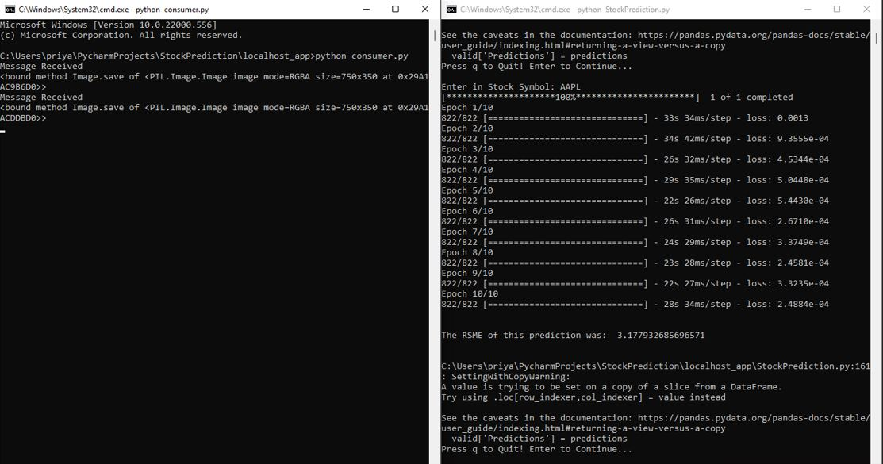

Predicted results in Kafka Topic:

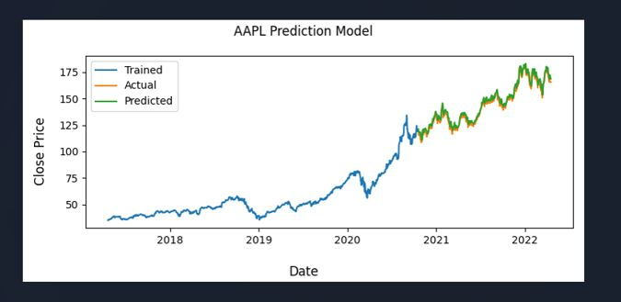

Summary and Conclusion:
We implemented stock market prediction using the LSTM model. The stock market plays a remarkable role in our daily lives. It is a significant factor in a country's GDP growth

Appendix
Stockprediction.py: Code for training and fitting the model. The file is in Python format.
App.py: Code for Kafka producer. The file is in python format
main.py: Code for Kafka consumer. The file is in python format
Docker-compose: Codes for docker compose for Kafka topic. The file is in xml format.

Reference:
https://www.analyticsvidhya.com/blog/2021/10/machine-learning-for-stock-market-prediction-with-step-by-step-implementation/

